Subject: November: Financial Literacy Month
Hello,
We care about your long-term financial wellness, which is why we provide you with a group retirement savings plan.
November is Financial literacy month in Canada. For the occasion, iA Financial Group, our group retirement savings plan provider, is launching a communication campaign that will take place throughout the month.
If you have requested to receive iA Financial Group's group retirement savings newsletters, you will receive Financial literacy month newsletters in November. Tools will be provided to help you:
- Better understand the current economic context
- Take stock of your financial situation
- Take the right actions to reach your financial goals
iA Financial Group will also be launching a contest where you could win several prizes, including $1,000 in groceries!
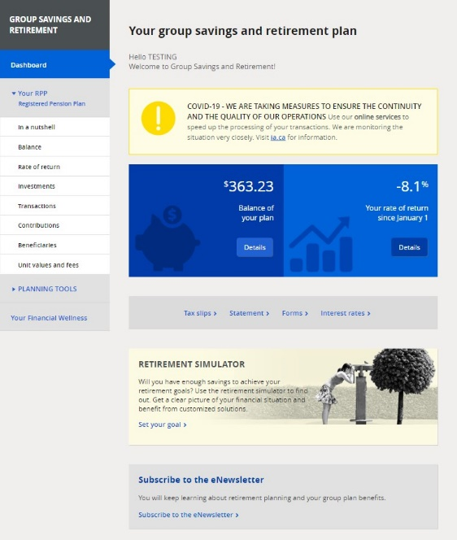
Make sure you receive the iA Financial Group newsletters so you don't miss anything! If you haven't already done so, subscribe now.
- Log in to My Client Space at ia.ca/myaccount and click on your Group Savings and Retirement plan dashboard.
- If the newsletter box appears at the bottom of the home page, simply click on "Subscribe to the eNewsletter".

Best regards,

Plan sponsor's signature

